California Building Energy Code Compliance (CBECC) Software Specification for Heat Recovery Chillers

Introduction
This report is intended to assist CBECC software developers with understanding the theory and application of heat recovery chillers as well as understand the capabilities and limitations of CBECC in modeling heat recovery chillers. In addition, a few changes are proposed for the standard design (baseline energy models) in CBECC.

Technical Basis for Software Change
A heat recovery chiller is a type of chiller system used for both cooling and heating purposes. It operates by recovering waste heat generated during the cooling process and repurposing it for heating applications, thereby improving energy efficiency. Heat recovery chillers are highly efficient systems that help reduce energy consumption and operating costs by utilizing waste heat for heating purposes, making them environmentally friendly and cost-effective solutions for both commercial and industrial applications.
“Double bundle” heat recovery chillers are an established technology that is offered by major chiller manufacturers. The term “double bundle” refers to the fact that there are two condenser coils, one for sending excess energy to a cooling tower, the other with full condensing heat exchanger for returning energy to a separate hot water loop in the building. This chiller can also operate as a cooling-only chiller at normal condensing temperature. Sometimes this equipment is referred to in the industry as a “6-pipe” unit. Figure 1 provides a snapshot of Trane double bundle heat recovery chiller. A rapidly growing category of heat recovery chillers can be classified as “dedicated” or “modular” equipment. One example product is shown in Figure 2.

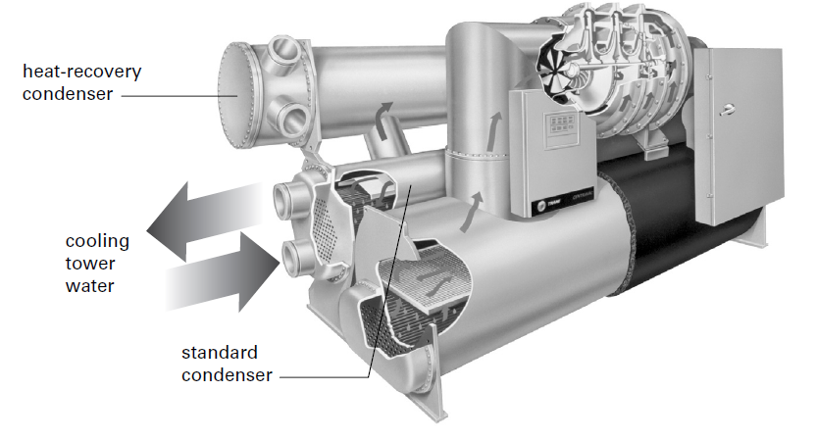
Figure 1. Dual bundle heat recovery centrifugal chiller
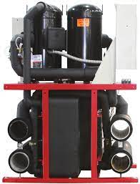
Figure 2. Dedicated heat recovery chiller

Water-Cooled Heat Recovery Chillers

Double Bundled Heat Recovery Chiller
As per EnergyPlus engineering reference, the chiller object Chiller:Electric:EIR can model heat recovery where part of its condenser section is connected to a heat recovery loop for what is commonly known as a double bundle chiller or single condenser with split bundles. The heat recovery chiller is simulated as a standard vapor compression refrigeration cycle with a double bundled condenser. A double bundle condenser involves two separate flow paths through a split condenser. One of these paths is condenser water typically connected to a standard cooling tower; the other path is hot water connected to a heat recovery loop. After leaving the compressor, the refrigerant is condensed to liquid in a refrigerant to water condenser. In a split bundle, the chiller’s internal controls will direct a part of the refrigerant to heat recovery condenser bundle and/or to the tower water condenser bundle depending on the chilled water load, the condenser inlet temperatures, and internal chiller controls (and possibly a leaving hot water temperature setpoint). The refrigerant pressure is then dropped through a throttling valve so that fluid can evaporate at a low pressure that provides cooling to the evaporator.

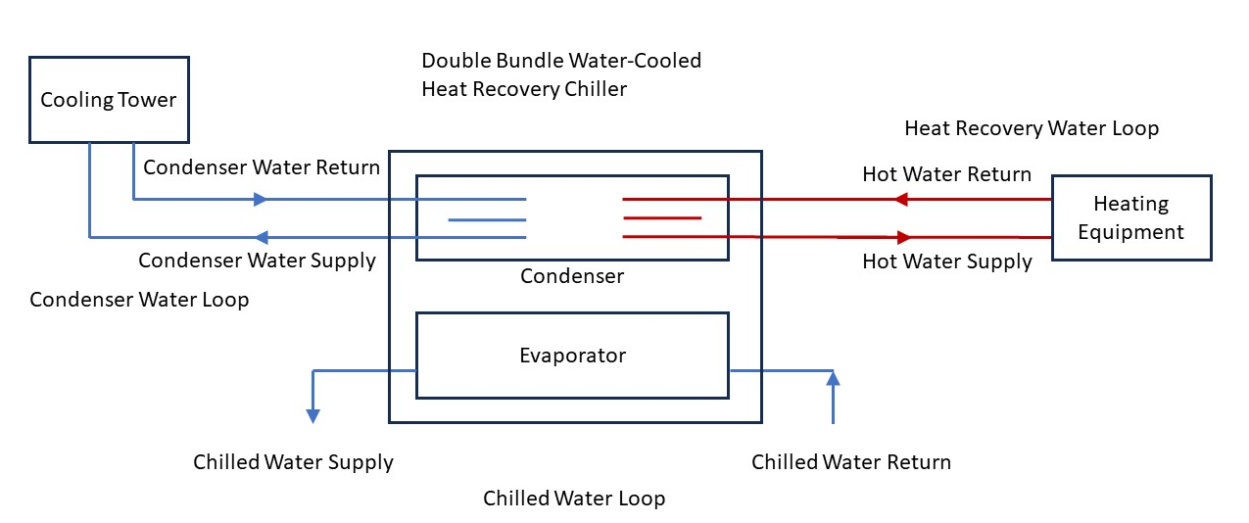
Figure 3. Schematic for double bundle water-cooled heat recovery chiller

The algorithm for the heat recovery portion of the chiller is determined from relatively simple inputs to estimate the amount of the heat that is recovered and then sends the rest of the waste heat to the cooling tower.

Design Heat Recovery Water Flow Rate
This is the design flow rate used if the heat recovery option is being simulated. Note that heat recovery is only available with CondenserType = WaterCooled.

Condenser Heat Recovery Relative Capacity Fraction
This fraction describes the relative capacity of the heat recovery bundle of a split condenser compared to the nominal, full load heat rejection rate of the chiller. This fraction will be applied to the full heat rejection when operating at nominal capacity and nominal COP to model a capacity limit for the heat rejection. If this field is not entered, the capacity fraction is set to 1.0.

Dedicated Heat Recovery Chiller
The EnergyPlus object (CHILLERHEATERPERFORMANCE:ELECTRIC:EIR) simulates the performance of a chiller-heater which can receive pre-cooled or pre-heated water from the source loop, and provide cooling, heating, or simultaneous cooling-heating. The object needs to work with the Central Heat Pump System object to be controlled properly. This model does not simulate thermal performance or the power consumption of associated pumps or cooling towers. The Central Heat Pump System object holds the input/output nodes connection of the chiller-heater and its control scheme once the chiller-heater is properly referred.
The model uses user-input performance information at design conditions along with three performance curves (curve objects) for cooling capacity and efficiency to determine chiller operation at off-design conditions. Three additional performance curves for heating capacity and efficiency are used when the chiller is operating in a heating-only mode or simultaneous cooling-heating mode.

Cooling-only Mode
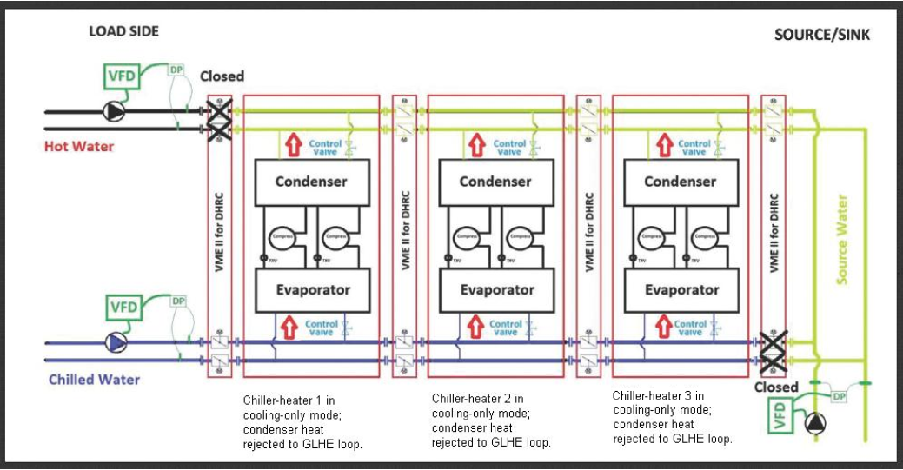
Figure 4. Schematic of a central heat pump system with three chiller-heaters in cooling-only mode (Condensers reject heat to GLHE)

Cooling Mode Cooling Capacity Function of Temperature Curve
As shown in Figure 4 for cooling only mode, the Cooling model Cooling Capacity Function of Temperature Curve represents the fraction of the cooling capacity of the chiller-heater as it varies by temperature. The curve should have a value of 1.0 at the reference conditions. The output of a bi-quadratic curve with the input variables being the leaving chilled water temperature and either the entering or leaving condenser water temperature is given by:

$$EvapCapFTclg = a+b\left(LChWT\right)+{c\left(LChWT\right)}^{2}+d\left(ECWT\right)+{e\left(ECWT\right)}^{2}+f \left(LChWT\right)\left(ECWT\right)$$
Equation 4: Cooling Capacity as Function of Temperature
Where:
$EvapCapFTclg$ is Cooling capacity factor, equal to 1 at reference conditions.
$LChWT$ is Leaving chilled water setpoint temperature (°C).
$ECWT$ is Entering condenser fluid temperature (°C). For a water-cooled condenser this will be the water temperature returning from the condenser loop (e.g., leaving the cooling tower).

Cooling Mode Electric Input to Cooling Output Ratio Function of Temperature Curve
The Cooling Mode Electric Input to Cooling Output Ratio Function of Temperature curve represents the fraction of electricity to the chiller-heater at full load as it varies by temperature. The output of a bi-quadratic curve with the input variables being the leaving chilled water temperature and either the entering or leaving condenser water temperature is given by:
$$EIRFTclg= a+b(LChWT)+{c(LChWT)}^{2}+d(ECWT)+{e(ECWT)}^{2}+f (LChWT) (ECWT)$$
Equation 5: Electric Input to Cooling Output Ratio Function of Temperature
Where:
$EIRFTclg$ is Energy input to cooling output factor, equal to 1 at reference conditions.
$LChWT$ is Leaving chilled water setpoint temperature (°C)
ECWT is Entering condenser fluid temperature (°C). For a water-cooled condenser this will be the water temperature returning from the condenser loop (e.g., leaving the cooling tower).

Heating-only mode and Simultaneous cooling-heating mode

Figures 5, 6, and 7³ depict the schematics of heating only model and simultaneous cooling-heating mode for dedicated heat recovery chiller.
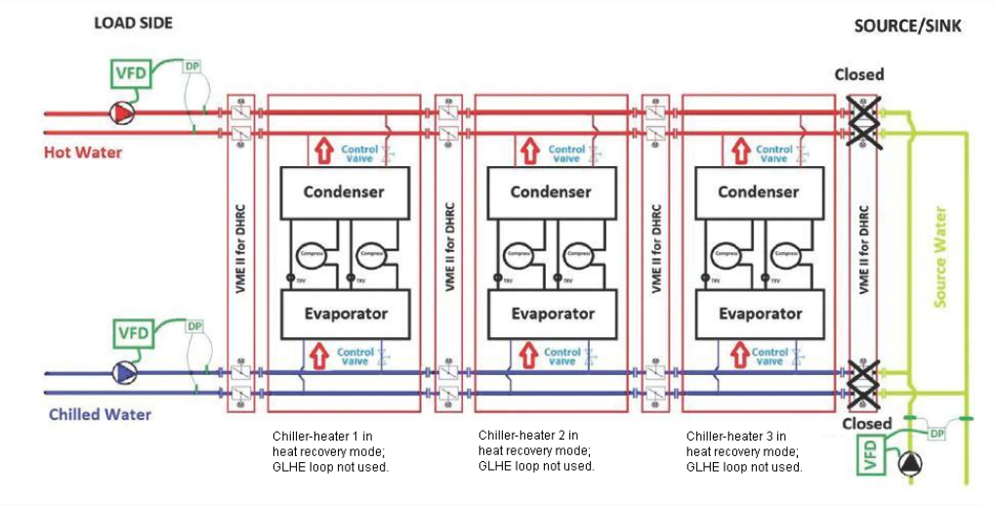
Figure 5. Schematic of a central heat pump system with three chiller-heaters in heat recovery mode (No heat is exchanged with the ground source loop)

Figure 6: Schematic of a central heat pump system with one chiller-heater in heat recovery mode and two chiller-heaters in cooling-only mode

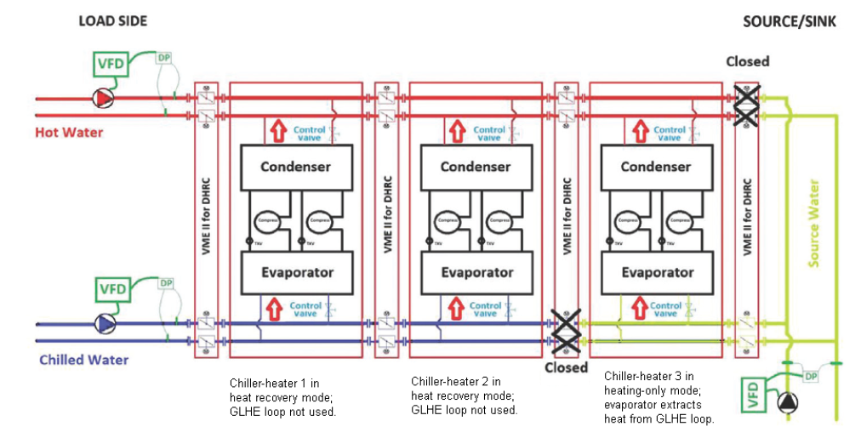
Figure 7: Schematic of a central heat pump system with two chiller-heaters in heat recovery mode and one chiller-heater in heating-only mode

Heating Mode Cooling Capacity Function of Temperature Curve
The output of a Heating Mode Cooling Capacity Function of Temperature curve with the input variables being the leaving chilled water temperature and either the entering or leaving condenser water temperature is given by:
$$EvapCapFThtg = a+b\left(LChWT\right)+{c\left(LChWT\right)}^{2}+d\left(ECWT\right)+{e\left(ECWT\right)}^{2}+f \left(LChWT\right)\left(ECWT\right)$$
Equation 6: Cooling Capacity as Function of Temperature
Where:
$EvapCapFThtg$ is heat mode Cooling capacity factor, equal to 1 at reference conditions.
$LChWT$ is Leaving chilled water setpoint temperature (°C).
$ECWT$ is Entering condenser fluid temperature (°C). For a water-cooled condenser this will be the water temperature returning from the condenser loop (e.g., leaving the cooling tower).

Heating Mode Electric Input to Cooling Output Ratio Function of Temperature Curve
The output of a Heating Mode Cooling Output Ratio Function of Temperature curve with the input variables being the leaving chilled water temperature and either the entering or leaving condenser water temperature is given by:
$$EIRFThtg= a+b(LChWT)+{c(LChWT)}^{2}+d(ECWT)+{e(ECWT)}^{2}+f (LChWT) (ECWT)$$
Equation 7: Electric Input to Cooling Output Ratio Function of Temperature
Where:
$EIRFThtg$ is Energy input to cooling output factor, equal to 1 at reference conditions.
$LChWT$ is Leaving chilled water setpoint temperature (°C)
ECWT is Entering condenser fluid temperature (°C). For a water-cooled condenser this will be the water temperature returning from the condenser loop (e.g., leaving the cooling tower).

Description of Software Change
Background Information for Software Change
In 2023, we conducted the data collection for heat recovery chillers that suggested that in the current market, the dedicated heat recovery chiller onlyhas water and air-cooled condensers. However, as addressed in the previous section, EnergyPlus dedicated heat recovery chiller object (CHILLERHEATERPERFORMANCE:ELECTRIC:EIR) only has water-cooled condenser and not air-cooled condenser. Therefore, this report mainly describes how the double bundle heat recovery can be implemented in CBECC.
Existing EnergyPlus Building Energy Modeling Capabilities
CBECC currently doesn’t model the Standard Design with the heat recovery chillers.
Summary of Proposed Revisions to CBECC
Several new EnergyPlus objects will be added to CBECC software in order to model the double bundle heat recovery chillers. The interface of CBECC also needs to be revised accordingly to let the users to select and edit the double bundle heat recovery chillers as depicted in Figure 3.
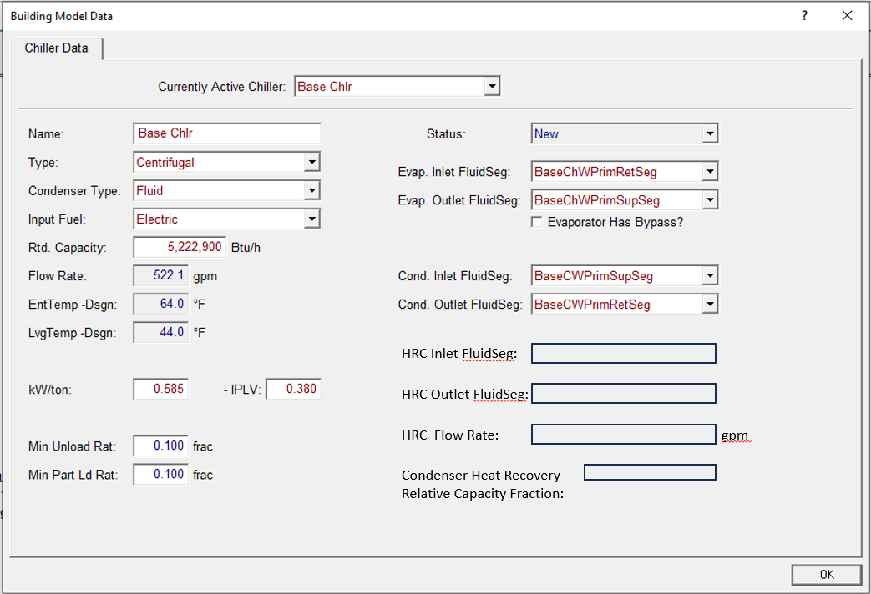
Figure 3. Double bundle heat recovery interface

Simulation Engine Inputs
EnergyPlus Inputs
Tables 1 to 9 summarizes the relevant EnergyPlus input variables specific to double bundle heat recovery.

Table 1. Description of EnergyPlus input variables relevant to Heat recovery chillers (Sizing:Plant).
Target EnergyPlus Object = Sizing:Plant
EnergyPlus Field | Default Value |  | Allowable Values
Design Loop Exit Temperature {C} | 54.44°C | ≥37.78°C
Loop Design Temperature Difference {deltaC} | 13.89°C | >0°C
Sizing Option | NonCoincident | ---
Zone Timesteps in Averaging Window | 1 | ---
Coincident Sizing Factor Mode | None | ---

Table 2. Description of EnergyPlus input variables relevant to Heat recovery chillers (Schedule:Day:Interval)
Target EnergyPlus Object = Schedule:Day:Interval
EnergyPlus Field | Default Value |  | Allowable Values
Interpolate to Timestep | No | ---
Time 1 {hh:mm} | 24:00 | ---
Value Until Time 1 | 54.44°C | ≥37.78°C

Table 3. Description of EnergyPlus input variables relevant to Heat recovery chillers (Chiller:Electric:EIR)
Target EnergyPlus Object = Chiller:Electric:EIR
EnergyPlus Field | Default Value |  | Allowable Values
Design Heat Recovery Water Flow Rate {m³/s} | --- | ---
Heat Recovery Inlet Node Name | Chiller Heat Rec Inlet Node | ---
Heat Recovery Outlet Node Name | Chiller Heat Rec Outlet Node | ---
Heat Recovery Leaving Temperature Setpoint Node Name | Chiller Heat Rec Outlet Node | ---

Table 4. Description of EnergyPlus input variables relevant to Heat recovery chillers (WaterHeater:Mixed)
Target EnergyPlus Object = WaterHeater:Mixed
EnergyPlus Field | Default Value |  | Allowable Values
Tank Volume {m³} | NA | ---
Setpoint Temperature Schedule Name | Dummy Water Heater Setpoint | ---
Deadband Temperature Difference {deltaC} | 0 | ---
Maximum Temperature Limit {C} | 100°C | ---
Heater Control Type | CYCLE | ---
Heater Maximum Capacity {W} | 0 W | ---
Heater Fuel Type | Electricity | ---
Heater Thermal Efficiency | 1 | ---
Ambient Temperature Indicator | Outdoors | ---
Ambient Temperature Outdoor Air Node Name | Dummy Water Heater OA Node | ---
Off Cycle Loss Coefficient to Ambient Temperature {W/K} | 0 | ---
Off Cycle Loss Fraction to Zone | 0 | ---
On Cycle Loss Coefficient to Ambient Temperature {W/K} | 0 W/K | ---
On Cycle Loss Fraction to Zone | 0 | ---
Use Side Inlet Node Name | BaseHWSystem-user Supply Inlet Pipe Node | ---
Use Side Outlet Node Name | Dummy Water Heater Use Side Outlet Node | ---
Use Side Effectiveness | 1.0 | ---
Source Side Inlet Node Name | Dummy Water Heater Source Side Inlet Node | ---
Source Side Outlet Node Name | Dummy Water Heater Source Side Outlet Node | ---
Source Side Effectiveness | 1.0 | ---
Use Side Design Flow Rate {m3/s} | Autosize | ---
Source Side Design Flow Rate {m3/s} | Autosize | ---

Table 5. Description of EnergyPlus input variables relevant to Heat recovery chillers.
Target EnergyPlus Object = PlantLoop
EnergyPlus Field | Default Value |  | Allowable Values
Fluid Type | Water | ---
Plant Equipment Operation Scheme Name | Heat Recovery Loop Operation | ---
Loop Temperature Setpoint Node Name | Heat Recovery Supply Outlet Node | ---
Maximum Loop Temperature {C} | 98°C | ---
Minimum Loop Temperature {C} | 10°C | ---
Maximum Loop Flow Rate {m3/s} | autosize | ---
Minimum Loop Flow Rate {m3/s} | 0 m³/s | ---
Plant Loop Volume {m3} | autocalculate | ---
Plant Side Inlet Node Name | Heat Recovery Demand Inlet Node | ---
Plant Side Outlet Node Name | Heat Recovery Demand Outlet Node | ---
Plant Side Branch List Name | Heat Recovery Demand Side Branches | ---
Plant Side Connector List Name | Heat Recovery Demand Side Connectors | ---
Demand Side Inlet Node Name | Heat Recovery Supply Inlet Node | ---
Demand Side Outlet Node Name | Heat Recovery Supply Outlet Node | ---
Demand Side Branch List Name | Heat Recovery Supply Side Branches | ---
Demand Side Connector List Name | Heat Recovery Supply Side Connectors | ---
Load Distribution Scheme | Optimal | ---

Table 6. Description of EnergyPlus input variables relevant to Heat recovery chillers.
Target EnergyPlus Object = PlantEquipmentList
EnergyPlus Field | Default Value |  | Allowable Values
Name | Heat Recovery Plant Equipment List | ---
Equipment 1 Object Type | WaterHeater:Mixed | ---
Equipment 1 Name | Dummy Water Heater | ---

Table 7. Description of EnergyPlus input variables relevant to Heat recovery chillers.
Target EnergyPlus Object = PlantEquipmentOperation:HeatingLoad
EnergyPlus Field | Default Value |  | Allowable Values
Load Range 1 Lower Limit {W} | 0 W | ---
Load Range 1 Upper Limit {W} | 1000000000000000 W | ---
Range 1 Equipment List Name | Heat Recovery Plant Equipment List | ---

Table 8. Description of EnergyPlus input variables relevant to Heat recovery chillers.
Target EnergyPlus Object = PlantEquipmentOperationSchemes
EnergyPlus Field | Default Value |  | Allowable Values
Name | Heat Recovery Plant Equipment List | ---
Control Scheme 1 Object Type | PlantEquipmentOperation:HeatingLoad | ---
Control Scheme 1 Name | Dummy Water Heater Only | ---
Control Scheme 1 Schedule Name | PlantOnSched | ---

Table 9. Description of EnergyPlus input variables relevant to Heat recovery chillers.
Target EnergyPlus Object = CondenserEquipmentOperationSchemes
EnergyPlus Field | Default Value |  | Allowable Values
Name | Heat Recovery Plant Equipment List | ---
Control Scheme 1 Object Type | PlantEquipmentOperation:CoolingLoad | ---
Control Scheme 1 Name | BaseCWSystem-user Cooling Operation Scheme | ---
Control Scheme 1 Schedule Name | Always On Discrete | ---

Simulation Engine Output Variables
CBECC generates hourly EnergyPlus simulation results to CSV files during analysis. These hourly simulation results can be used by the analyst to debug a building energy model. Variables of particular interest in this case would include:
- Water Heater Heating Rate,timestep; !- HVAC Average [W]
- Water Heater Heating Energy,timestep; !- HVAC Sum [J]
- Chiller Evaporator Inlet Temperature,timestep; !- HVAC Average [C]
- Chiller Evaporator Outlet Temperature,timestep; !- HVAC Average [C]
- Chiller Evaporator Mass Flow Rate,timestep; !- HVAC Average [kg/s]
- Chiller Condenser Inlet Temperature,timestep; !- HVAC Average [C]
- Chiller Condenser Outlet Temperature,timestep; !- HVAC Average [C]
- Chiller Condenser Mass Flow Rate,timestep; !- HVAC Average [kg/s]
- Chiller Total Recovered Heat Rate,timestep; !- HVAC Average [W]
- Chiller Total Recovered Heat Energy,timestep; !- HVAC Sum [J]
- Chiller Heat Recovery Inlet Temperature,timestep; !- HVAC Average [C]
- Chiller Heat Recovery Outlet Temperature,timestep; !- HVAC Average [C]
- Chiller Heat Recovery Mass Flow Rate,timestep; !- HVAC Average [kg/s]
- Water Heater Use Side Mass Flow Rate,timestep; !- HVAC Average [kg/s]
- Water Heater Use Side Inlet Temperature,timestep; !- HVAC Average [C]
- Water Heater Use Side Outlet Temperature,timestep; !- HVAC Average [C]
- Water Heater Use Side Heat Transfer Rate,timestep; !- HVAC Average [W]
- Water Heater Use Side Heat Transfer Energy,timestep; !- HVAC Sum [J]
- Water Heater Source Side Mass Flow Rate,timestep; !- HVAC Average [kg/s]
- Water Heater Source Side Inlet Temperature,timestep; !- HVAC Average [C]
- Water Heater Source Side Outlet Temperature,timestep; !- HVAC Average [C]
- Water Heater Source Side Heat Transfer Rate,timestep; !- HVAC Average [W]
- Water Heater Source Side Heat Transfer Energy,timestep; !- HVAC Sum [J]

Sensitivity Analysis or Testing
To assess the impacts of different variables or input parameters on the energy consumption of heat recovery chillers, sensitivity analysis is required. Based on the current capability of EnergyPlus, the impact of weather conditions on annual energy consumption by heat recovery chillers in 16 California climate zones was analyzed for a CBECC hospital prototype building with a heat recovery chiller system.

Table 6. Heat recovery chillers Annual Electricity Use (kWh) for Different Climate Zones.
Climate zone | Heating Energy (kWh) | Cooling Energy (kWh) | Fans Energy (kWh) | Pumps Energy (kWh) | Heat Rejection Energy (kWh)
CZ 1 | 521,187 | 21,378 | 1,459,620 | 40,170 | 789
CZ 2 | 444,499 | 141,773 | 1,465,173 | 68,833 | 13,140
CZ 3 | 309,784 | 87,095 | 1,460,823 | 64,773 | 6,331
CZ 4 | 363,617 | 205,068 | 1,466,904 | 81,258 | 17,357
CZ 5 | 338,607 | 105,068 | 1,459,306 | 66,264 | 7,480
CZ 6 | 114,864 | 222,019 | 1,449,604 | 105,845 | 27,307
CZ 7 | 113,691 | 233,417 | 1,450,328 | 110,441 | 29,190
CZ 8 | 146,439 | 302,029 | 1,457,677 | 115,291 | 38,818
CZ 9 | 161,047 | 273,866 | 1,459,376 | 107,754 | 30,941
CZ 10 | 178,880 | 310,076 | 1,464,281 | 111,950 | 37,043
CZ 11 | 338,624 | 292,649 | 1,465,789 | 102,169 | 32,774
CZ 12 | 333,641 | 214,403 | 1,460,673 | 88,376 | 24,268
CZ 13 | 267,351 | 312,668 | 1,463,101 | 108,387 | 37,800
CZ 14 | 307,856 | 284,572 | 1,471,480 | 98,361 | 20,119
CZ 15 | 107,851 | 548,567 | 1,465,696 | 148,791 | 66,592
CZ 16 | 428,952 | 129,218 | 1,482,414 | 71,633 | 3,419

Comparison of Heat Recovery Objects between EnergyPlus 9.4 and 25.1
CBECC 2028 uses EnergyPlus 25.1 for building energy simulations. However, the original idf files for the heat recovery chiller were created in EnergyPlus 9.4, which is a significantly older version. EnergyPlus does not support direct conversion of IDF files across multiple major versions, as each version may introduce new objects, rename or deprecate existing objects, reorder fields, or change default values and calculation methods. Therefore, to update the idf files from version 9.4 to 25.1, it is necessary to use a sequence of transition programs provided by EnergyPlus. Each transition program handles a single-version upgrade, applying the appropriate modifications to object names, fields, and values to ensure compatibility with the next version. By running this chain of transition programs sequentially, the idf files can be systematically migrated to EnergyPlus 25.1 while preserving their functional integrity as listed below. Table 7 listed the annual electricity end use by using EnergyPlus 25.1 version of the idf files for heat recovery chillers. The updated annual energy end uses are consistent with the previous modeling results. The change of the total HVAC energy consumption is in the range of -1.51% to 0.18%.
- TransitionV9-4-0-to-V9-5-0
- TransitionV9-5-0-to-V9-6-0
- TransitionV9-6-0-to-V22-1-0
- TransitionV22-1-0-to-V22-2-0
- TransitionV22-2-0-to-V23-1-0
- TransitionV23-1-0-to-V23-2-0
- TransitionV23-2-0-to-V24-1-0
- TransitionV24-1-0-to-V24-2-0
- TransitionV24-2-0-to-V25-1-0

Table 7. Heat Recovery Chillers Annual Electricity Use (kWh) for Different Climate Zones with EnergyPlus 25.1
Climate zone | Heating Energy (kWh) | Cooling Energy (kWh) | Fans Energy (kWh) | Pumps Energy (kWh) | Heat Rejection Energy (kWh)
CZ 1 | 522,095 | 17,099 | 1,459,967 | 36,328 | 761
CZ 2 | 447,453 | 137,202 | 1,465,437 | 65,558 | 13,145
CZ 3 | 312,244 | 79,643 | 1,461,035 | 58,707 | 6,272
CZ 4 | 370,437 | 199,387 | 1,467,339 | 77,328 | 17,352
CZ 5 | 341,571 | 99,734 | 1,459,746 | 62,368 | 7,463
CZ 6 | 124,527 | 214,637 | 1,450,234 | 100,252 | 27,134
CZ 7 | 105,260 | 226,171 | 1,449,903 | 104,569 | 28,863
CZ 8 | 148,780 | 296,104 | 1,457,875 | 111,145 | 38,415
CZ 9 | 158,712 | 267,351 | 1,459,386 | 102,986 | 30,895
CZ 10 | 178,136 | 304,158 | 1,464,242 | 108,019 | 36,857
CZ 11 | 328,957 | 287,331 | 1,465,569 | 98,562 | 32,737
CZ 12 | 347,377 | 208,404 | 1,461,243 | 84,026 | 24,211
CZ 13 | 256,950 | 307,637 | 1,462,765 | 104,855 | 37,738
CZ 14 | 328,674 | 278,339 | 1,472,179 | 94,299 | 20,165
CZ 15 | 101,841 | 544,183 | 1,465,396 | 146,115 | 66,486
CZ 16 | 416,463 | 117,026 | 1,482,300 | 64,596 | 3,409

After updating the idf files from EnergyPlus 9.4 to 25.1, we conducted a detailed comparison of all objects related to the heat recovery chiller between the two versions. The comparison included object names, field order, input values, and default parameters. The results show that there were no changes in any of the heat recovery chiller objects, indicating that the update process preserved their configuration and functionality across versions.

Future Research
We are currently working with LBNL to implement Time Dependent Energy Recovery (TIER) System into EnergyPlus. TIER systems typically include chilled water air handlers, VAV boxes with hot water reheat, and water-cooled heat recovery chillers as illustrated in Figure 3. Additional heating is typically provided by air source heat pumps, though gas boilers can be used as well. Additional heat rejection is typically provided by water-cooled chillers served by cooling towers. The details of the system and its various operating modes is described in-depth in Brandon Gill’s 2021 ASHRAE Journal article titled “Solving the Large Building All-Electric Heating Problem.”
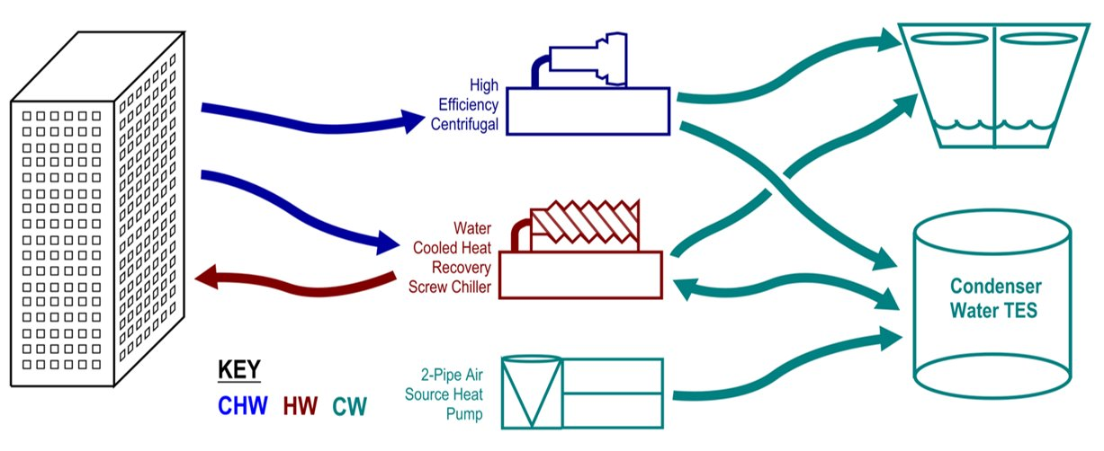
Figure 3. TIER Schematic (Gill 2021)​

Since August 2023, the CASE team has been collaborating with LBNL to enhance EnergyPlus capabilities to be able to model systems such as TIER. LBNL has developed implementation strategies of the TIER system and several EnergyPlus objects were selected as listed below.

- WaterHeater:Stratified with 0 capacity or stand-alone TES hot water storage tank
- Air-to-water heat pump: model with HeatPump:PlantLoop:EIR:Heating object
- Heat recovery chiller: ChillerHeaterPerformance:Electric:EIR. Can model heating and cooling-driven chillers.
- Control and connections: Python API with potential enhancements to PlantEquipmentOperation:ChillerHeaterChangeover (adding a control scheme)

LBNL development work is ongoing as of February 2024. The CASE team has periodic check in meetings with LBNL staff to track progress toward deliverables. The CASE Team (Jeff Stein) developed a simplified sequence of operations for the LBNL team which we felt was helpful to show here as well, though this effort is not relevant to CBECC developers until the EnergyPlus engine is enhanced first.

Appendix: Taylor Engineers Basic TIER Plant SOO For BEM
Developed by Jeff Stein, July 25, 2023

Basic TIER Plant Sequences of Operation for Energy Simulations
  - CHILLER STAGING
- CO CH(s) (cooling-only chillers) and HR CH (heat recovery chillers) are staged based on cooling load, with all CO CH staged on (and fully loaded) before any HR CH are staged on.
- HR CH(s) are also staged based on heating load – e.g. no HR chillers at 0 load, then 1 HR CH, then 2 HR CH if heat load exceeds heat capacity of 1 HR CH, etc. If a HR CH is called to run by cooling load then it is last in staging order for heating load, i.e. better to run one HR in cooling and another in heating then to run 1 or 2 in cooling+heating.
  - CHILLER INDEXING
- CO CH evaporator is indexed to CHW loop, condenser is indexed to CW loop.
- How the HR chiller evaporator and condenser are indexed depends on whether the HR chiller is called to run by the cooling staging and/or by the heating staging, per table below.
Staged on by: | Evaporator indexed to: | Condenser indexed to:
Cooling load only | CHW loop | CW loop
Heating load only | CW loop | HW loop
Cooling and heating load (note: this is unlikely to occur) | CHW loop | HW loop + CW loop, if necessary*
*If the cooling load + compressor heat > heating load then excess waste heat is transferred to CW loop.
  - TES TANK
- Parameters
  - Gallons
  - Stratification dT (default: 20F)
  - Max top tank temp (default: 80F). Tank is 100% charged when top temp = max.
  - Min bottom tank temp (default: 42F). Tank is 0% charged when bottom temp = min.
- When CH evaporators are indexed to CW loop their water flow is from top of tank to evap and then from evap to bottom of tank. Assume CH evaporator dT matches stratification dT.
- When CH condensers are indexed to CW loop their water flows from bottom of tank to condenser and then from condenser to top of tank. Assume CH condenser dT matches stratification dT.
- If net CH btuh to CW loop is positive, then tank top and bottom temps will rise at same rate, calculated based on net btuh and gallons. Likewise, tank temps fall if net CH btuh is negative.
  - COOLING TOWERS (CT)
- Enable all cooling towers when tank is 100% charged and net CH btuh to CW loop is positive. Disable otherwise.
- Tank bypass: If CT is enabled then bypass TES tank.
- Modulate CT fan speed per existing E+ sequences.
  - CT PUMPS
- Modulate CT pump speed to maintain HX dT on CT side = HX dT on closed CW side, but not below speed corresponding to CT min flow.
  - CLOSED CONDENSER WATER PUMPS (PULL FROM BOTTOM OF TANK)
- Enabled when any CH condenser is indexed to CW loop. Disabled otherwise.
- Flow rate based on heat rejected to CW loop by condensers and stratification dT.
  - CONDENSER WATER EVAPORATOR PUMPS (PULL FROM TOP OF TANK)
- Enabled when any CH evaporator is indexed to CW loop. Disabled otherwise.
- Flow rate based on evaporator heat transfer and stratification dT.
  - AIR-SOURCE HEAT PUMPS (ASHP)
- All ASHP are enabled when Tank Charge% ≤ ASHP-Charge% (default: 1%) and disabled otherwise. NOTE: If there are unmet load hours using default for ASHP-Charge% then user should raise ASHP-Charge% to “pre-charge” the tank.
- ASHP setpoint shall be tank bottom temp + stratification dT.
- ASHP has dedicated constant speed primary pump?
  - AIR ECONOMIZER HIGH LIMITS
- All airside economizer shall be disabled when either of the following are true and enabled when both are false.
  - OAT > RAT (or whatever is the normal sequence for disabling the economizer)
  - Tank Charge% ≤ Econ-Charge% (default: 20%)
  - NOTES:
- Creating a false CHW load by disabling the economizer is more efficient than using the ASHP to charge the tank, so Econ-Charge% should be greater than ASHP-Charge%.
- Raising Econ-Charge% higher than necessary is inefficient because it wastes CH and CT energy, i.e. filling the tank with heat rejection from false CHW loads leaves less room in the tank for heat rejection from real CHW loads.
- Modeler is encouraged to iterate on ASHP-Charge% and Econ-Charge% to minimize UMLH and annual energy.

Trane Engineers newsletter, “Water-side heat recovery” URL: https://www.trane.com/content/dam/Trane/Commercial/global/products-systems/education-training/engineers-newsletters/waterside-design/admapn023en_0207.pdf
Amermec, “NRP-0800-1800_Y_NA60_04_Data-Sheet-1.” URL: https://www.aermec.us/wp-content/uploads/2023/10/NRP-0800-1800_Y_NA60_04_Data-Sheet-1.pdf
EnergyPlus™ Version 9.4.0 Documentation Input Output Reference, U.S. Department of EnergySeptember 29, 2020
https://tayloreng.egnyte.com/dl/hHl2ZkZRDC/ASHRAE_Journal_-_Solving_the_Large_Building_All-Electric_Heating_Problem.pdf_

